DSA0602-Class Activity 2

- Smart City Air Quality Monitoring
Python code :
import numpy as np
import pandas as pd
import matplotlib.pyplot as plt
import seaborn as sns
np.random.seed(10)
n = 150
df = pd.DataFrame({
"X": np.random.randint(0,100,n),
"Y": np.random.randint(0,100,n),
"PM25": np.random.randint(20,300,n),
"NO2": np.random.randint(10,120,n),
"CO": np.random.uniform(0.2,4,n),
"Temp": np.random.randint(20,40,n),
"Humidity": np.random.randint(30,90,n)
})
fig,ax=plt.subplots(1,3,figsize=(18,5))
ax[0].scatter(df.X,df.Y,c=df.PM25,cmap='Reds',s=80)
ax[0].set_title("Sequential")
ax[1].scatter(df.X,df.Y,c=df.PM25-150,cmap='coolwarm',s=80)
ax[1].set_title("Diverging")
ax[2].scatter(df.X,df.Y,c=np.random.randint(0,5,n),cmap='Set2',s=80)
ax[2].set_title("Qualitative")
plt.tight_layout()
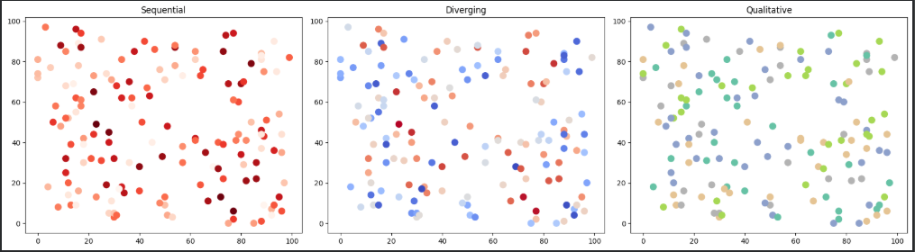
plt.show()
R-program
library(ggplot2)
set.seed(10)
n <- 150
df <- data.frame(
X = sample(1:100, n, replace = TRUE),
Y = sample(1:100, n, replace = TRUE),
PM25 = sample(20:300, n, replace = TRUE)
)
ggplot(df, aes(X, Y, color = PM25)) +
geom_point(size = 4) +
scale_color_gradient(low = "yellow", high = "red") +
ggtitle("Smart City Air Quality Monitoring")
Output Screenshot

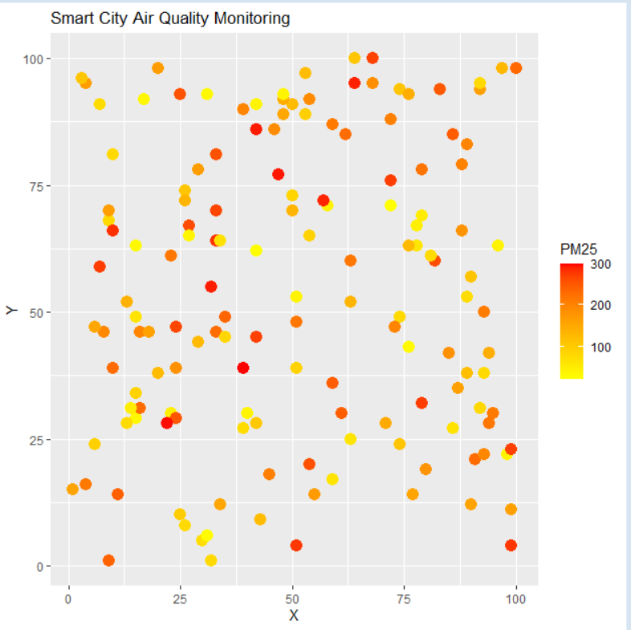

- Earthquake Risk Analysis
Python code:
import numpy as np
import pandas as pd
import matplotlib.pyplot as plt
np.random.seed(20)
n=500
df=pd.DataFrame({
"Magnitude":np.random.uniform(0.5,9.5,n),
"Depth":np.random.randint(1,700,n)
})
plt.figure(figsize=(12,5))
plt.subplot(1,2,1)
plt.scatter(df.Depth,df.Magnitude,c=df.Magnitude,cmap='viridis')
plt.title("Linear Scale")
plt.subplot(1,2,2)
plt.scatter(df.Depth,df.Magnitude,c=df.Magnitude,cmap='plasma')
plt.xscale('log')
plt.title("Log Scale")
plt.tight_layout()
plt.show()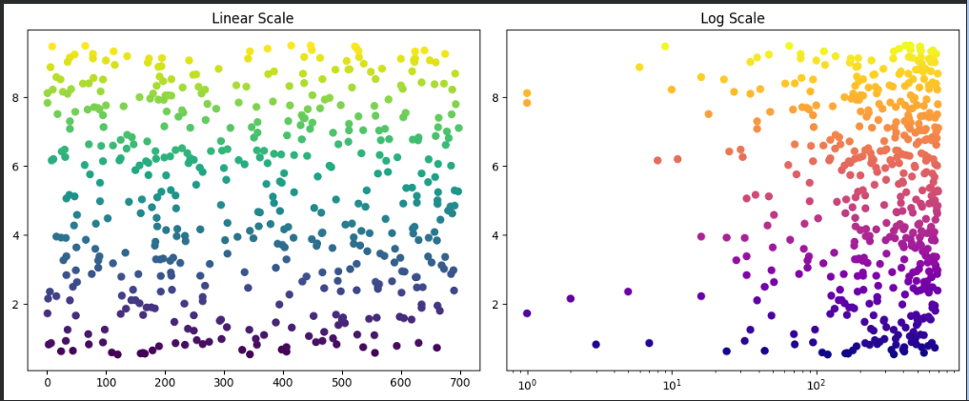

R-Program:
library(ggplot2)
set.seed(20)
df <- data.frame(
Magnitude = runif(500, 0.5, 9.5),
Depth = sample(1:700, 500, replace = TRUE)
)
ggplot(df, aes(Depth, Magnitude, color = Magnitude)) +
geom_point() +
ggtitle("Linear Scale")
ggplot(df, aes(Depth, Magnitude, color = Magnitude)) +
geom_point() +
scale_x_log10() +
ggtitle("Log Scale")
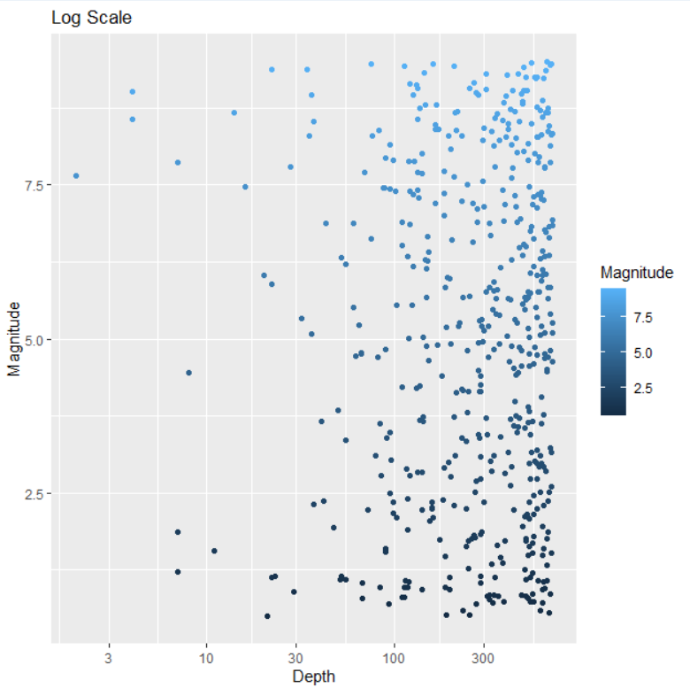

- Wind Direction Analysis
Python Code:
import numpy as np
import matplotlib.pyplot as plt
np.random.seed(30)
direction=np.random.randint(0,360,365)
speed=np.random.uniform(5,40,365)
plt.figure(figsize=(12,5))
plt.subplot(1,2,1)
plt.scatter(direction,speed,c=speed,cmap='viridis')
plt.xlabel("Direction")
plt.ylabel("Speed")
plt.title("Cartesian Plot")
ax=plt.subplot(1,2,2,projection='polar')
theta=np.deg2rad(direction)
ax.scatter(theta,speed,c=speed,cmap='jet')
ax.set_title("Wind Rose")
plt.tight_layout()
plt.show()

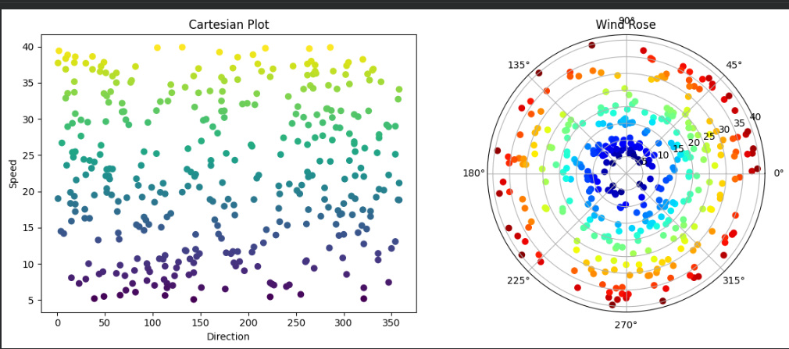

R-program
library(ggplot2)
set.seed(30)
df <- data.frame(
Direction = sample(0:359, 365, replace = TRUE),
Speed = runif(365, 5, 40)
)
ggplot(df, aes(Direction, Speed, color = Speed)) +
geom_point() +
ggtitle("Cartesian Plot")
ggplot(df, aes(Direction, Speed, fill = Speed)) +
geom_bar(stat = "identity") +
coord_polar() +
ggtitle("Polar Plot")

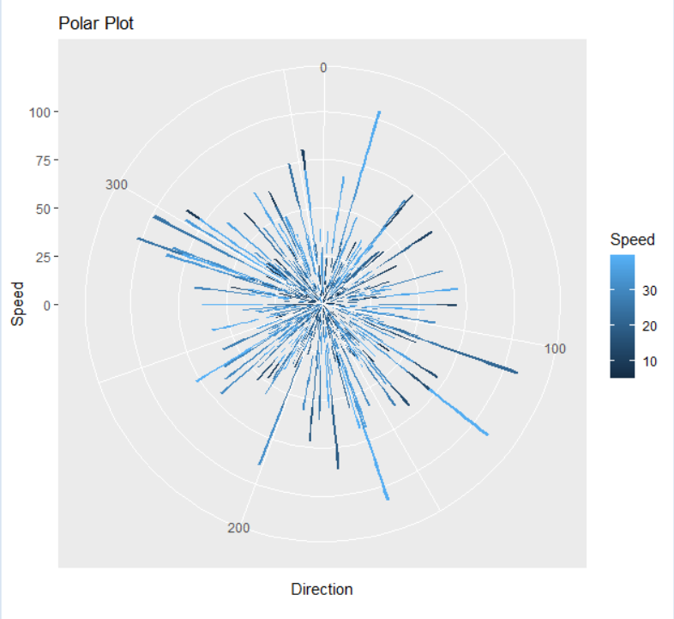
- Hospital Patient Monitoring Dashboard

Python code:

import pandas as pd

import numpy as np

import matplotlib.pyplot as plt

np.random.seed(40)

time=np.arange(100)

heart=np.random.randint(60,130,100)

oxygen=np.random.randint(85,100,100)

plt.figure(figsize=(12,5))

plt.subplot(2,1,1)

plt.plot(time,heart,color='blue')

plt.scatter(time,heart,c=np.where(heart>100,'red','green'))

plt.title("Heart Rate")

plt.subplot(2,1,2)

plt.plot(time,oxygen,color='black')

plt.scatter(time,oxygen,c=np.where(oxygen<90,'red','green'))

plt.title("Oxygen Saturation")

plt.tight_layout()

plt.show()

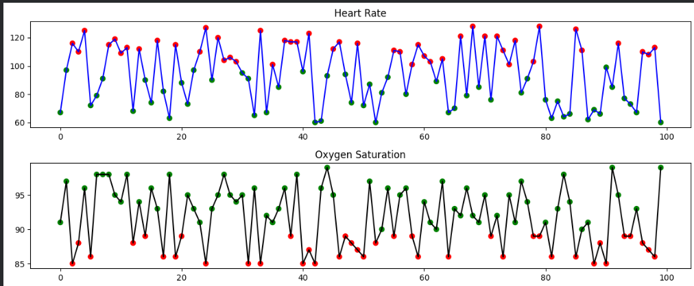

R-program
library(ggplot2)
set.seed(40)
time <- 1:100
heart <- sample(60:130, 100, replace = TRUE)

df <- data.frame(Time = time, HeartRate = heart)

ggplot(df, aes(Time, HeartRate, color = HeartRate > 100)) +
geom_line() +
geom_point(size = 2) +
scale_color_manual(values = c("green", "red")) +
ggtitle("Heart Rate Dashboard")

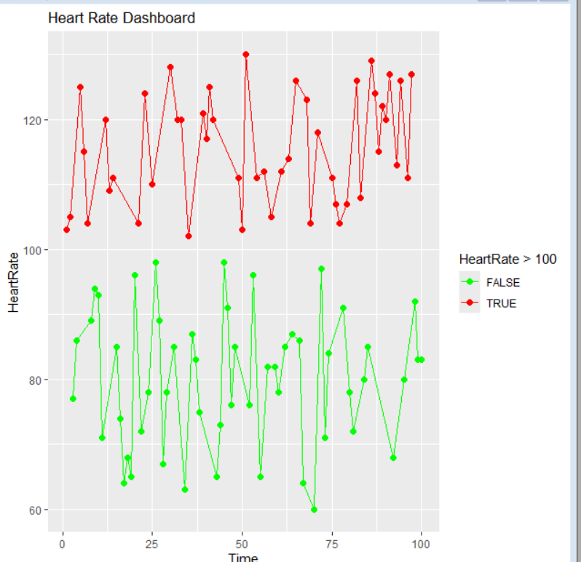

- Global Climate Change Study
Python code:
import numpy as np
import seaborn as sns
import matplotlib.pyplot as plt
np.random.seed(50)
data=np.random.uniform(-3,3,(20,20))
fig,ax=plt.subplots(1,3,figsize=(18,5))
sns.heatmap(data,cmap='coolwarm',ax=ax[0])
ax[0].set_title("Coolwarm")
sns.heatmap(data,cmap='RdBu_r',ax=ax[1])
ax[1].set_title("RdBu")
sns.heatmap(data,cmap='PiYG',ax=ax[2])
ax[2].set_title("PiYG")
plt.tight_layout()
plt.show()

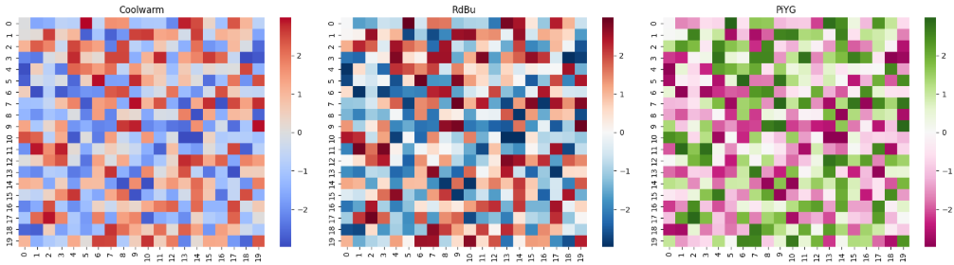

R-program
library(ggplot2)
library(reshape2)
set.seed(50)
data <- matrix(runif(400, -3, 3), nrow = 20)
df <- melt(data)

ggplot(df, aes(Var1, Var2, fill = value)) +
geom_tile() +
scale_fill_gradient2(low = "blue", mid = "white", high = "red") +
ggtitle("Climate Change Heatmap")

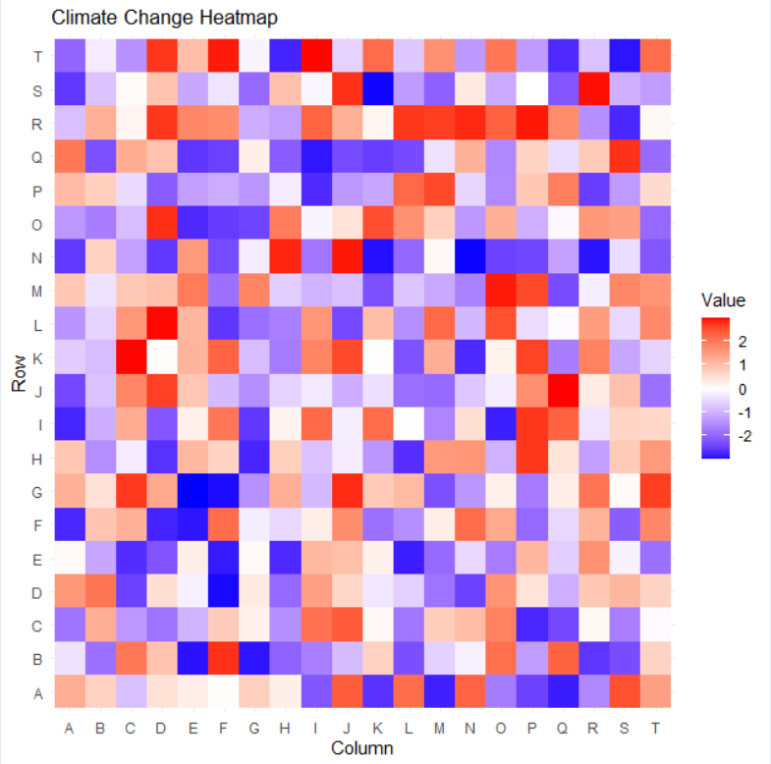

- E-Commerce Sales Analytics
Python code:\
import numpy as np
import pandas as pd
import matplotlib.pyplot as plt
np.random.seed(60)
categories=[f"C{i}" for i in range(1,11)]
sales=np.random.randint(1000,10000,10)
plt.figure(figsize=(10,5))
plt.bar(categories,sales,color=plt.cm.tab10(range(10)))
plt.scatter(categories,sales,c=sales,cmap='Reds',s=200)
plt.title("Sales Analytics")
plt.show()

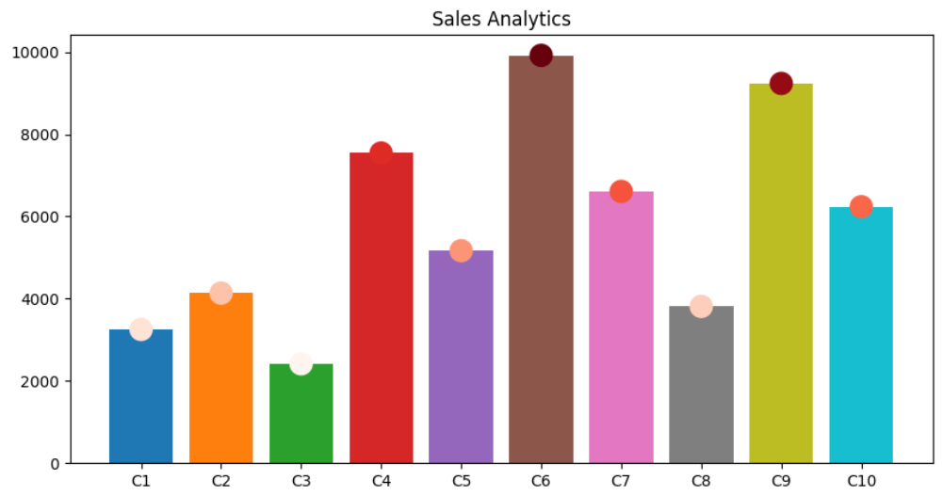
R-program:
library(ggplot2)

set.seed(60)

df <- data.frame(
Category = paste0("C",1:10),
Sales = sample(1000:10000,10)
)

ggplot(df,aes(Category,Sales,fill=Sales))+
geom_bar(stat="identity")+
scale_fill_gradient(low="lightblue",high="darkblue")+
ggtitle("Sales Analytics")

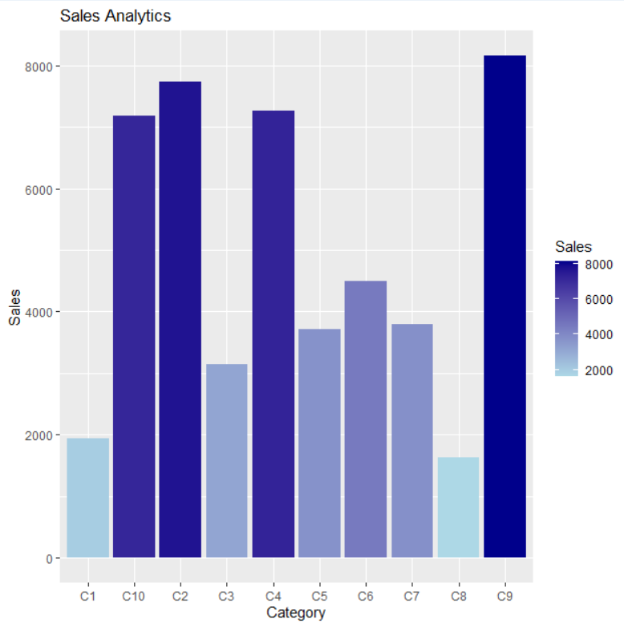
- Satellite Image Vegetation Analysis
Python code:
import numpy as np
import matplotlib.pyplot as plt
np.random.seed(70)
ndvi=np.random.uniform(-1,1,(30,30))
fig,ax=plt.subplots(1,2,figsize=(12,5))
ax[0].imshow(ndvi,cmap='Greens')
ax[0].set_title("Sequential")
ax[1].imshow(ndvi,cmap='RdYlGn')
ax[1].set_title("Diverging")
plt.show()

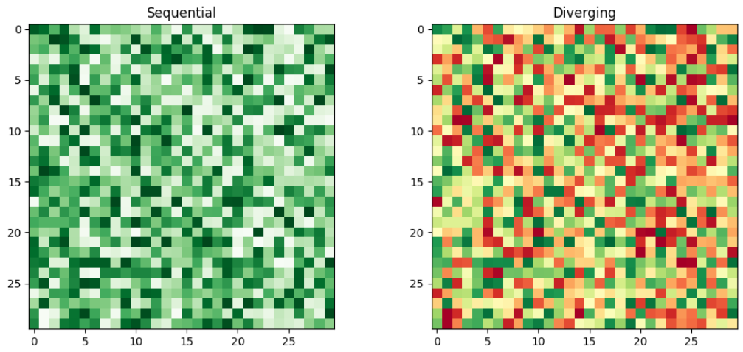

R-program

library(ggplot2)
library(reshape2)
set.seed(70)
mat <- matrix(runif(900,-1,1),30)
df <- melt(mat)
ggplot(df,aes(Var1,Var2,fill=value))+
geom_tile()+
scale_fill_gradient2(low="brown",mid="yellow",high="green")+
ggtitle("NDVI Vegetation Analysis")

